NAME – N.SHIVANI

REGISTRATION NO –

MODULE NAME – APPLIED AI (MD -11)

Project Title
Car Price Prediction Dashboard Using Machine Learning

AIM
2. Car Price Prediction Dashboard
Problem:
Develop an interface to predict used car prices using features like year, fuel type, and mileage.
Task:
- Load and clean car dataset.
- Perform regression modeling.
- Visualize feature importance.
- Create user input interface.
- Display predicted price with charts.

Description
This project predicts the price of a used car based on features such as Year, Fuel Type, Mileage, and Transmission. A Random Forest Regression model is used to estimate the car price, and a Streamlit Dashboard provides an interactive interface for users to enter car details and view predictions.

Objectives
- Load and clean the car dataset.
- Preprocess the data.
- Train a regression model.
- Predict car prices.
- Visualize feature importance.
- Create an interactive dashboard.
- Manage the project using GitHub.

Tools and Technologies
- Python
- Pandas
- Scikit-learn
- Matplotlib
- Streamlit
- Git & GitHub

Methodology
- Load the car dataset.
- Clean and preprocess the data.
- Encode categorical features.
- Train a Random Forest Regression model.
- Create a Streamlit dashboard.
- Predict car prices based on user input.
- Display feature importance and price distribution charts.

GitHub Workflow
- Create a GitHub repository.
- Add project files and dataset.
- Initialize Git using git init.
- Commit changes using git commit.
- Push code using git push.
- Create branches for updates.
- Use Pull Requests for collaboration.

Result
The system accurately predicts used car prices and displays the results through an interactive dashboard with charts and visualizations.
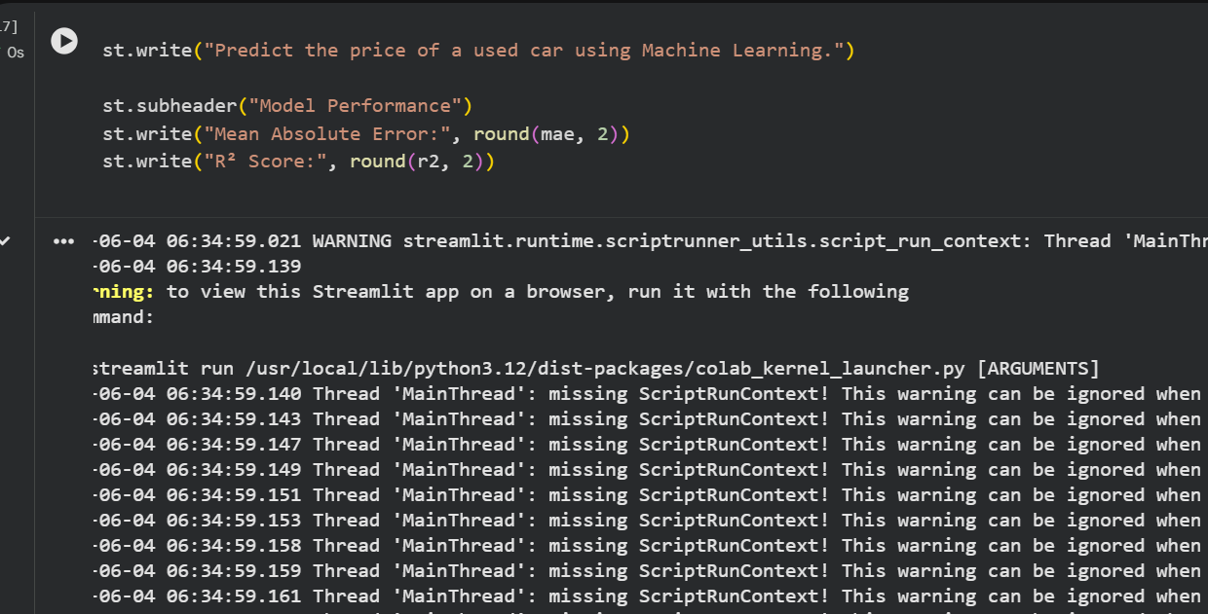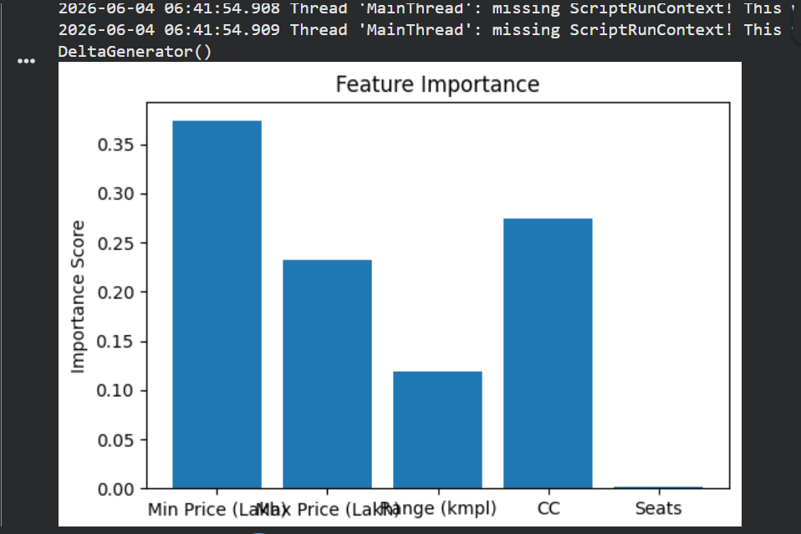

Conclusion
This project demonstrates the use of Machine Learning, Data Visualization, Streamlit, and GitHub to build a practical car price prediction application.

